Year 8 Music Test

Link the key words on the left below to the correct definition on the right.

|  |  |  |
| --- | --- | --- |
| Verse |  | A new section in the middle of a popular song |
|  |  |  |
| Chorus |  | Usually has the same melody but different lyrics. Songs often have 2 minimum. |
|  |  |  |
| Bridge |  | A link between the verse and chorus |
|  |  |  |
| Pre-chorus |  | The start of a song |
|  |  |  |
| Introduction |  | A section of a song that is often repeated with the same lyrics and melody |
|  |  |  |
| Outro |  | A happy sounding chord |
|  |  |  |
| Solo |  | 3 or more notes played together |
|  |  |  |
| Major |  | A section that is made up during the performance |
|  |  |  |
| Minor |  | An instrumental section in the middle of a song |
|  |  |  |
| Chord |  | The end section of a song |
|  |  |  |
| Triad |  | A simple 3 note chord |
|  |  |  |
| Improvisation |  | A minor sounding chord |

Mark the keys on the keyboard that you would play for the chords below. An example is provided.

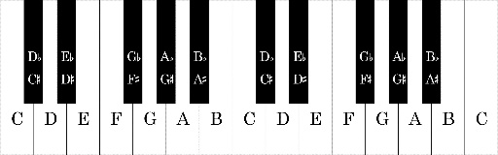

D Minor

 

C Major F Major

 

A minor G Major

What is the meaning of the following terms:

A Capella

__________________________________________________________________________________

__________________________________________________________________________________

Harmony

__________________________________________________________________________________

__________________________________________________________________________________

Give 2 features that are common in Rock ‘n’ Roll music

__________________________________________________________________________________

__________________________________________________________________________________

__________________________________________________________________________________

__________________________________________________________________________________